Topic:TryHackMe: Windows Fundamentals 1
Lab Overview
Platform: TryHackMe
Room:Windows Fundamentals 1
Status: Completed
1. Windows Editions
In this section, I learned about the different versions of the Windows operating system and how Windows has evolved over time. Windows has been widely used in home and corporate environments, which also makes it a common target for hackers and malware.
I learned about major Windows versions such as Windows XP, Vista, Windows 7, Windows 8.x, Windows 10, and Windows 11. The current desktop version mentioned in the room is Windows 11, which comes in Home and Pro editions.
The section also introduced Windows Server 2019 Standard as the edition used by the attached VM.

The question asked:
“What encryption can you enable on Pro that you can't enable in Home?”
My answer was: BitLocker
Why: BitLocker is a Windows encryption feature available in supported Pro editions that is not available in Windows Home editions. It can be used to encrypt drives and help protect data if a device is lost or accessed without authorization.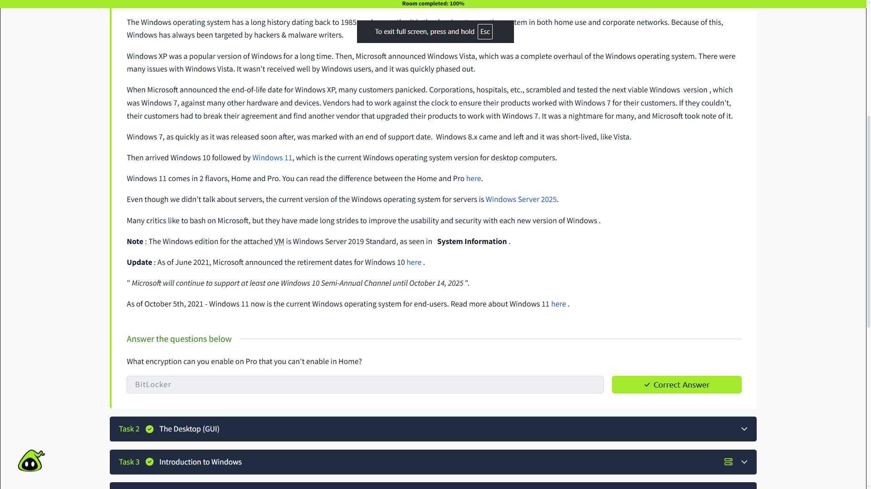

2. The Desktop (GUI)
In this section, I learned about the Windows Desktop, also known as the Graphical User Interface (GUI). It is the main screen that appears after logging into Windows.
I learned about the main components of the Windows GUI:
- Desktop
- Start Menu
- Search Box
- Task View
- Taskbar
- Toolbars
- Notification Area
I also learned that the Taskbar can be customized by right-clicking it. The Search box and Task View button can be enabled or disabled from the Taskbar settings. The Notification Area displays the clock, network, volume, and other system icons.

Questions and Answers
1. Which selection will hide/disable the Search box?
My answer was: Hidden
Why: In the Taskbar settings, the Search option can be changed to Hidden, which removes the Search box from the taskbar. Electronics Reference

2. Which selection will hide/disable the Task View button?
My answer was: Show Task View button
Why: The Show Task View button option controls whether the Task View button is displayed on the taskbar. Disabling this option hides the button. Electronics Reference

3. Besides Clock and Network, what other icon is visible in the Notification Area?
My answer was: Action Center
Why: The Action Center icon is visible in the Notification Area and provides access to Windows notifications and related quick actions.
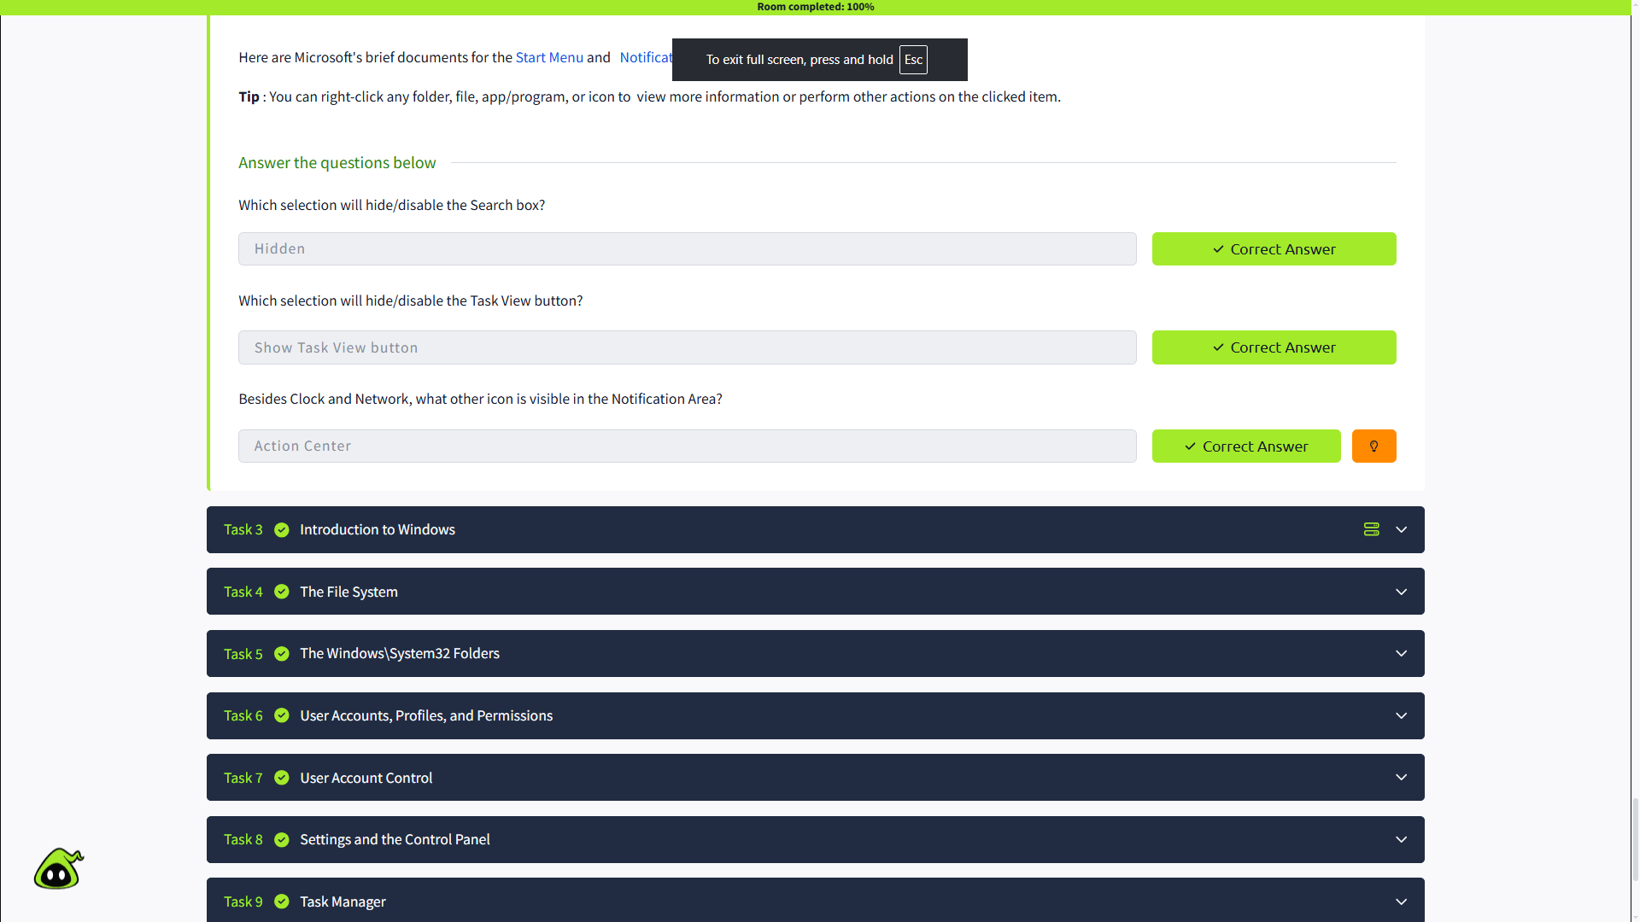

3. Introduction to Windows
In this section, I learned how to set up the Windows lab environment for the room. The lab requires starting the Lab Machine and, when needed, the AttackBox.
The section introduced the Windows operating system as a complex system containing system files, utilities, settings, and other features. The purpose of the room is to provide a general understanding of Windows, including navigating the user interface and making changes to the system.
For the practical part, I started the lab machine and accessed the Windows environment provided by TryHackMe.

The question asked:
“Read above and start the lab machine.”
My answer was: Completed
Why: I started the TryHackMe Windows lab machine as required before continuing with the room.

4. The File System
In this section, I learned about the NTFS (New Technology File System), which is the file system used by modern versions of Windows.
I learned that before NTFS, Windows used file systems such as FAT16/FAT32 and HPFS. NTFS is a journaling file system, meaning it can use information stored in a log to help repair files and folders after a failure.
Some important features of NTFS include:
- Supports files larger than 4 GB
- Allows specific permissions for files and folders
- Supports file and folder compression
- Supports encryption through EFS (Encrypting File System)
I also learned about NTFS permissions, such as Full Control, Modify, Read & Execute, List Folder Contents, Read, and Write.
Another feature covered was Alternate Data Streams (ADS). ADS allows a file on an NTFS volume to contain additional streams of data. From a security perspective, malware can potentially use ADS to hide data.

The question asked:
“What is the meaning of NTFS?”
My answer was: New Technology File System
Why: NTFS stands for New Technology File System and is the modern Windows file system discussed in this section.
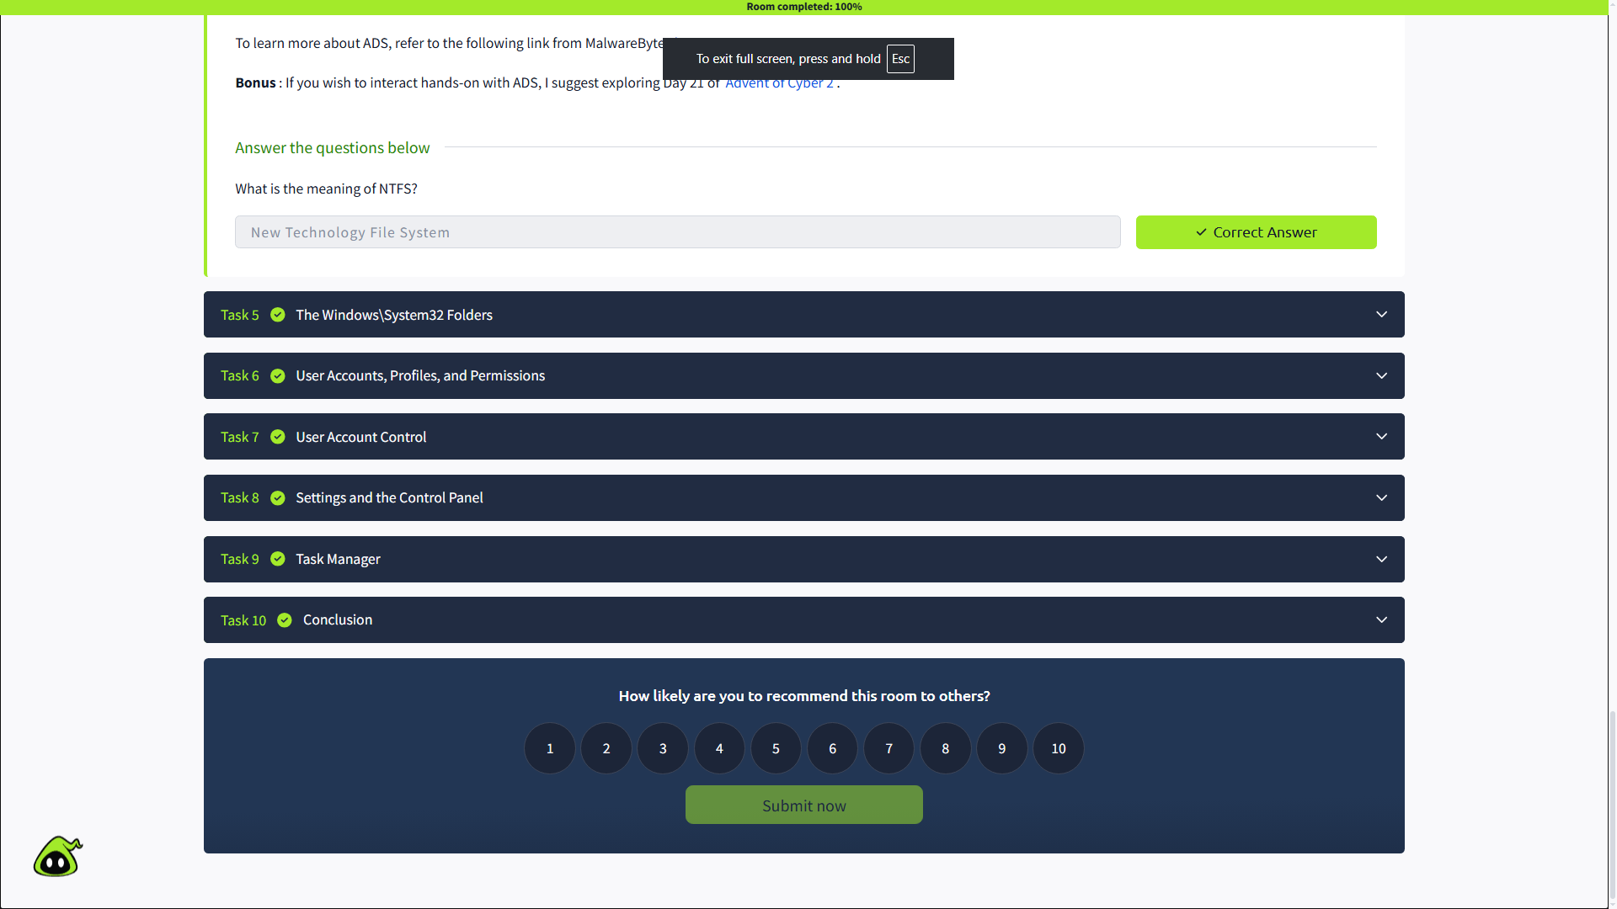

5. The Windows\System32 Folders
In this section, I learned about the Windows folder (C:\Windows), which contains important files and components of the Windows operating system.
I learned that the Windows folder does not necessarily have to be located on the C drive. The location can be represented using the %windir% environment variable.
I also learned about the System32 folder. It contains important files and tools that are critical to the Windows operating system. Because of this, files and folders inside System32 should be handled carefully, as deleting important files can cause Windows to stop working properly.

The question asked:
“What is the system variable for the Windows folder?”
My answer was: %windir%
Why: The source explains that %windir% is the system environment variable used to represent the location of the Windows directory.
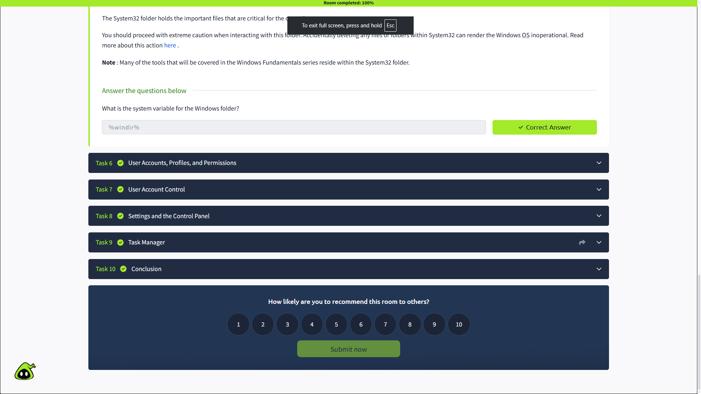

6. User Accounts, Profiles, and Permissions
In this section, I learned about user accounts, user profiles, and permissions in Windows.
Windows local user accounts are generally divided into two types:
- Administrator — can make system-level changes, such as adding or deleting users, modifying groups, changing settings, and installing programs.
- Standard User — has more limited permissions and generally cannot make system-level changes.
I also learned that when a new user account is created and logs in for the first time, Windows creates a user profile under:
C:\Users
A user profile contains folders such as Desktop, Documents, Downloads, Music, and Pictures.
The section also introduced Local Users and Groups Management, which can be opened using:
lusrmgr.msc
It contains two main sections: Users and Groups. Users can belong to multiple groups, and they inherit the permissions assigned to those groups.

Questions and Answers
1. What is the name of the other user account?
My answer was: [Enter the user account name shown in your lab]
Why: The exact account name depends on the Windows lab machine. It is found under Other users or Local Users and Groups → Users.

2. What groups is this user a member of?
My answer was: [Enter the groups shown in your lab]
Why: A user's group membership determines the permissions inherited by that user. The groups can be checked from the user's Properties → Member Of section.

3. What built-in account is for guest access to the computer?
My answer was: Guest
Why: Windows has a built-in Guest account intended for guest access with limited permissions.

4. What is the account description?
My answer was: [Enter the account description shown in your lab]
Why: The account description can be viewed from the user's properties in Local Users and Groups.
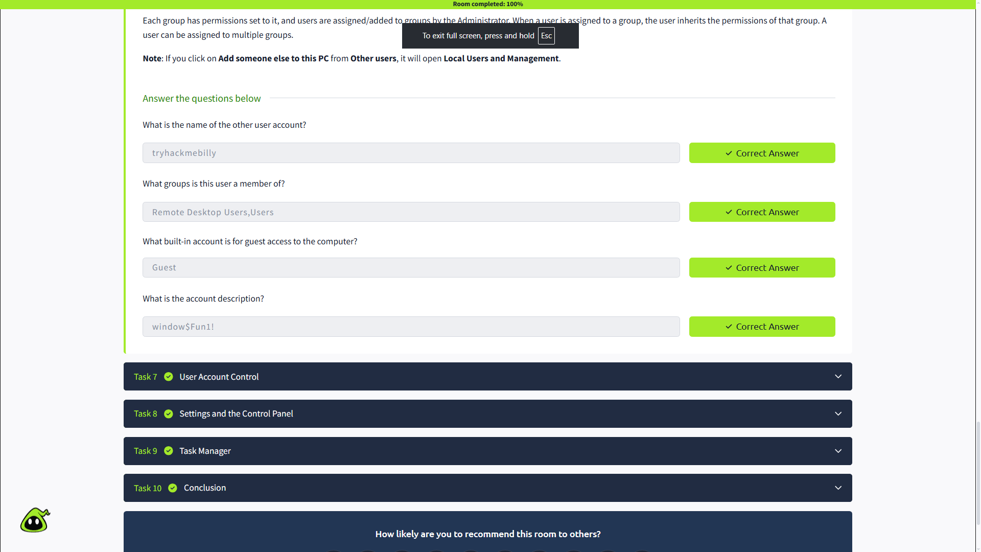

7. User Account Control
In this section, I learned about User Account Control (UAC) and how it helps protect Windows systems from unauthorized or potentially harmful system-level changes.
I learned that users with administrator accounts have elevated privileges, but they do not always need those privileges for normal activities such as browsing the Internet or working on documents. Running with unnecessary elevated privileges can increase the risk of malware compromising the system.
UAC helps reduce this risk by prompting the user for confirmation when an operation requires higher-level privileges.
I also learned that when a standard user tries to install a program requiring elevated privileges, a UAC prompt appears. The shield icon on a program can indicate that UAC will be involved.

The question asked:
“What does UAC mean?”
My answer was: User Account Control
Why: UAC stands for User Account Control. It is a Windows security feature that prompts for permission when an operation requires higher-level privileges. 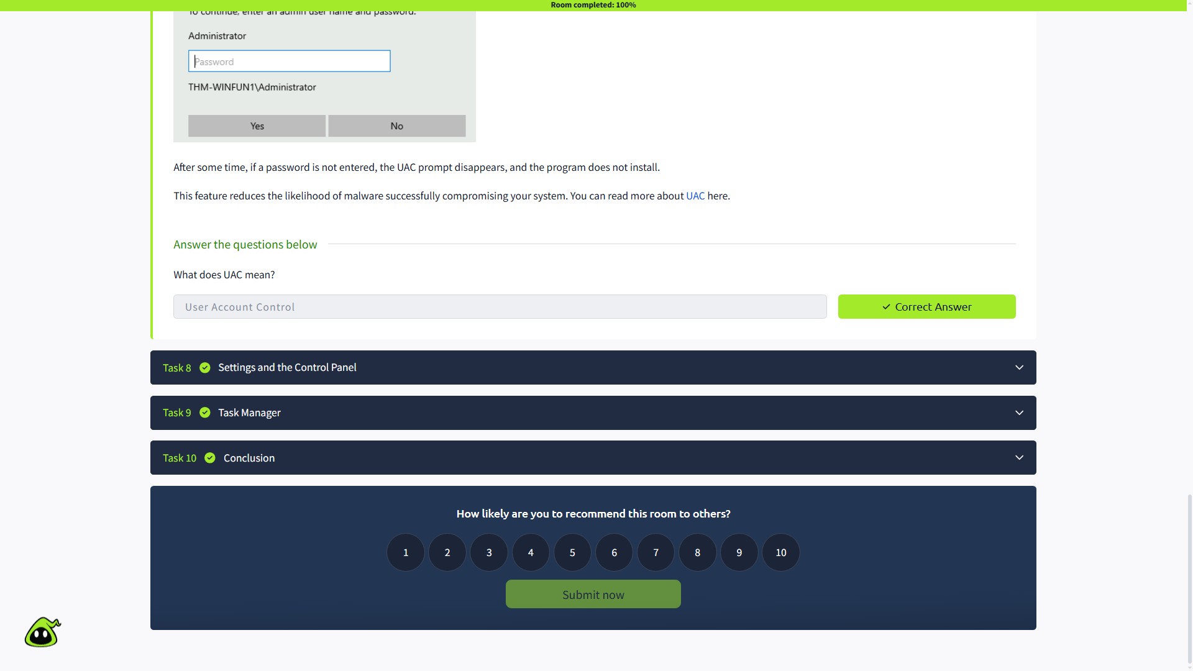
8. Settings and the Control Panel
In this section, I learned about two main places in Windows where system settings can be changed: Settings and the Control Panel.
The Control Panel has traditionally been used for system changes such as adding printers, uninstalling programs, and accessing more advanced settings. The Settings menu was introduced in Windows 8 and became the primary place for changing system settings in Windows 10.
I also learned that some settings may start in Settings but open a Control Panel window. For example, Network & Internet → Change adapter options can lead to Control Panel.
The Control Panel also has Programs and Features, which can be used to view installed applications, including their names, publishers, and versions.

The question asked:
“In the Control Panel, change the view to Small icons. What is the last setting in the Control Panel view?”
My answer was: Windows Defender Firewall
Why: After changing the Control Panel view to Small icons, Windows Defender Firewall appears as the last setting in the list in the TryHackMe lab environment.
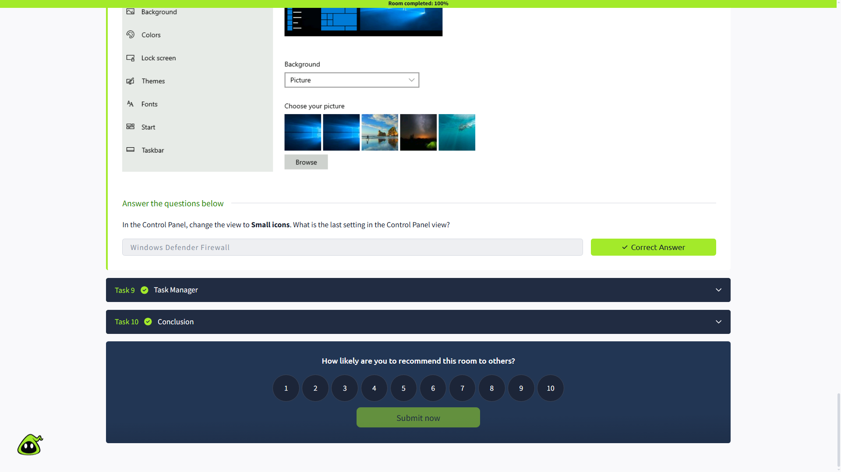

9. Task Manager
In this section, I learned about Task Manager, which provides information about the applications and processes currently running on a Windows system.
Task Manager also shows system performance information, including CPU and RAM usage. It can be opened by right-clicking the taskbar. By default, it opens in a simple view, and clicking More details displays additional information.
Task Manager is useful for viewing what is currently running on the system and checking resource usage.

The question asked:
“What is the keyboard shortcut to open Task Manager?”
My answer was: Ctrl + Shift + Esc
Why: Ctrl + Shift + Esc is the keyboard shortcut used to directly open Windows Task Manager.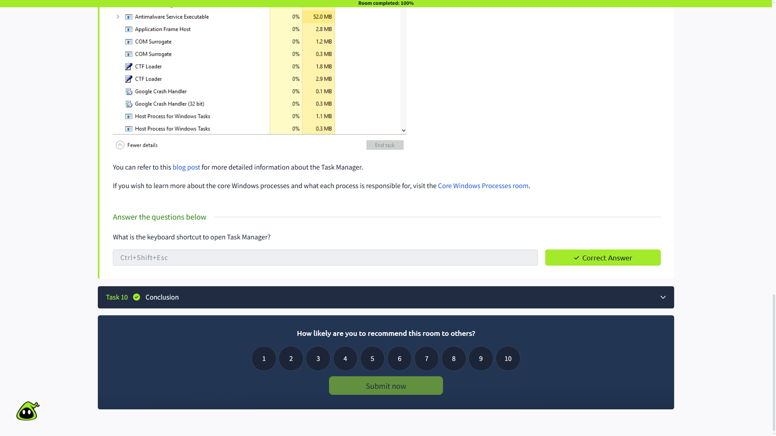

10. Conclusion
In this section, I learned that the room provided a general overview of the Windows operating system. The topics covered in this room can be explored further through intermediate and advanced Windows topics.
The room also mentioned that future modules will cover topics such as the Windows folder, Management Console, Windows Defender, and Windows Firewall.

The question asked:
“Read above and terminate the Windows machine you deployed in this room.”
My answer was: Completed
Why: I terminated the Windows lab machine after completing the room, as instructed.

